PE System Login and Position Review Instructions for Supervisors
- Log in to myUK (click here).
- Click on the “Manager Self Service” tab.
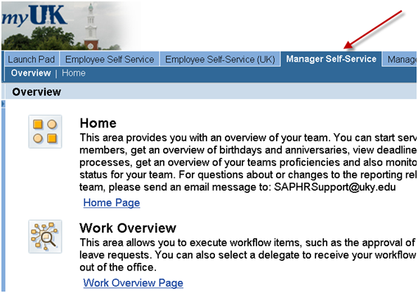
- In Manager Self-Service, click the Performance Goals and Evaluations link under Performance Management (see below). This should automatically take you directly to your SuccessFactors home page (no separate login required), and you may continue to step 4 below.
If you are instead prompted for another log in, click here for simple troubleshooting steps: Once you have completed these steps (to add SuccessFactors to your internet browser as a "trusted site"), click on the Performance Goals and Evaluations link once again, as shown below.
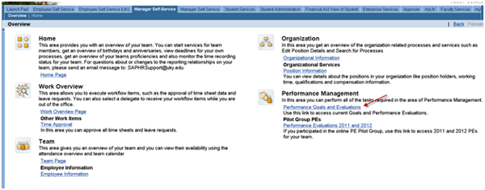

- Reviewing Employees' Position Description in the SuccessFactors Performance Evaluation System
On the PE system home page, your direct reports will display in the My Team tile. To see an employee’s Major Job Responsibilities, click on the tile with the employee’s name.
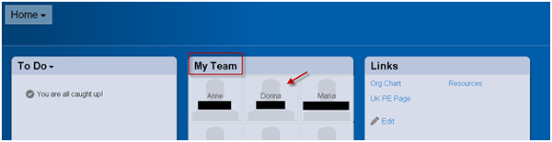
- Now click on the gear icon to the left of Actions.
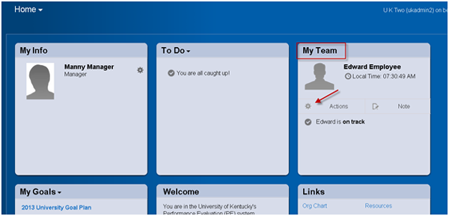
- Select Goal Plan in the pop-up window.
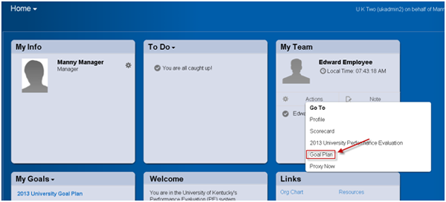
- To review major job responsibilities (MJRs), essential functions, and MJR percent weightings, select the appropriate Goal Plan in the dropdown box. If any updates are needed to the position description information, please visit this page for instructions.
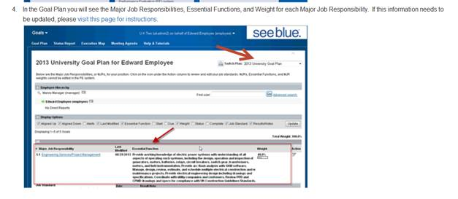​
Ready to begin? Log in to myUK now.

